Codd’s Rules in DBMS
Codd’s rules are proposed by a computer scientist named Dr. Edgar F. Codd and he also invent the relational model for database management. These rules are made to ensure data integrity, consistency, and usability. This set of rules basically signifies the characteristics and requirements of a relational database management system (RDBMS). In this article, we will learn about various Codd’s rules.
Codd’s Rules in DBMS
Rule 1: The Information Rule
All information, whether it is user information or metadata, that is stored in a database must be entered as a value in a cell of a table. It is said that everything within the database is organized in a table layout.
Rule 2: The Guaranteed Access Rule
Each data element is guaranteed to be accessible logically with a combination of the table name, primary key (row value), and attribute name (column value).
Rule 3: Systematic Treatment of NULL Values
Every Null value in a database must be given a systematic and uniform treatment.
Rule 4: Active Online Catalog Rule
The database catalog, which contains metadata about the database, must be stored and accessed using the same relational database management system.
Rule 5: The Comprehensive Data Sublanguage Rule
A crucial component of any efficient database system is its ability to offer an easily understandable data manipulation language (DML) that facilitates defining, querying, and modifying information within the database.
Rule 6: The View Updating Rule
All views that are theoretically updatable must also be updatable by the system.
Rule 7: High-level Insert, Update, and Delete
A successful database system must possess the feature of facilitating high-level insertions, updates, and deletions that can grant users the ability to conduct these operations with ease through a single query.
Rule 8: Physical Data Independence
Application programs and activities should remain unaffected when changes are made to the physical storage structures or methods.

Rule 9: Logical Data Independence
Application programs and activities should remain unaffected when changes are made to the logical structure of the data, such as adding or modifying tables.
Rule 10: Integrity Independence
Integrity constraints should be specified separately from application programs and stored in the catalog. They should be automatically enforced by the database system.
Rule 11: Distribution Independence
The distribution of data across multiple locations should be invisible to users, and the database system should handle the distribution transparently.
Rule 12: Non-Subversion Rule
If the interface of the system is providing access to low-level records, then the interface must not be able to damage the system and bypass security and integrity constraints.

Entity Relationship Diagram – ER Diagram in DBMS
An Entity–relationship model (ER model) describes the structure of a database with the help of a diagram, which is known as Entity Relationship Diagram (ER Diagram). An ER model is a design or blueprint of a database that can later be implemented as a database. The main components of E-R model are: entity set and relationship set.

What is an Entity Relationship Diagram (ER Diagram)?
An ER diagram shows the relationship among entity sets. An entity set is a group of similar entities and these entities can have attributes. In terms of DBMS, an entity is a table or attribute of a table in database, so by showing relationship among tables and their attributes, ER diagram shows the complete logical structure of a database. Lets have a look at a simple ER diagram to understand this concept.

Facts about ER Diagram Model:
ER model allows you to draw Database Design
It is an easy to use graphical tool for modeling data Widely used in Database Design
It is a GUI representation of the logical structure of a Database
It helps you to identifies the entities which exist in a system and the relationships between those entities

Why use ER Diagrams?

Here, are prime reasons for using the ER Diagram
Helps you to define terms related to entity relationship modeling
Provide a preview of how all your tables should connect, what fields are going to be on each table
Helps to describe entities, attributes, relationships
ER diagrams are translatable into relational tables which allows you to build databases quickly ER diagrams can be used by database designers as a blueprint for implementing data in specific software applications

A simple ER Diagram:
In the following diagram we have two entities Student and College and their relationship. The relationship between Student and College is many to one as a college can have many students however a student cannot study in multiple colleges at the same time. Student entity has attributes such as Stu_Id, Stu_Name & Stu_Addr and College entity has attributes such as Col_ID & Col_Name.
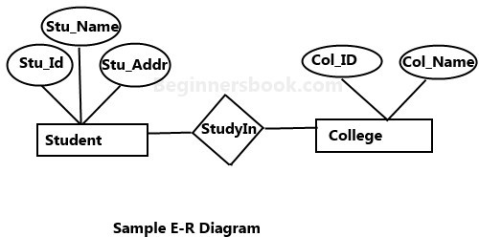

Here are the geometric shapes and their meaning in an E-R Diagram. We will discuss these terms in detail in the next section (Components of a ER Diagram) of this guide so don’t worry too much about these terms now, just go through them once.

Rectangle: Represents Entity sets.
Ellipses: Attributes
Diamonds: Relationship Set
Lines: They link attributes to Entity Sets and Entity sets to Relationship Set
Double Ellipses: Multivalued Attributes Dashed Ellipses: Derived Attributes Double Rectangles: Weak Entity Sets
Double Lines: Total participation of an entity in a relationship set

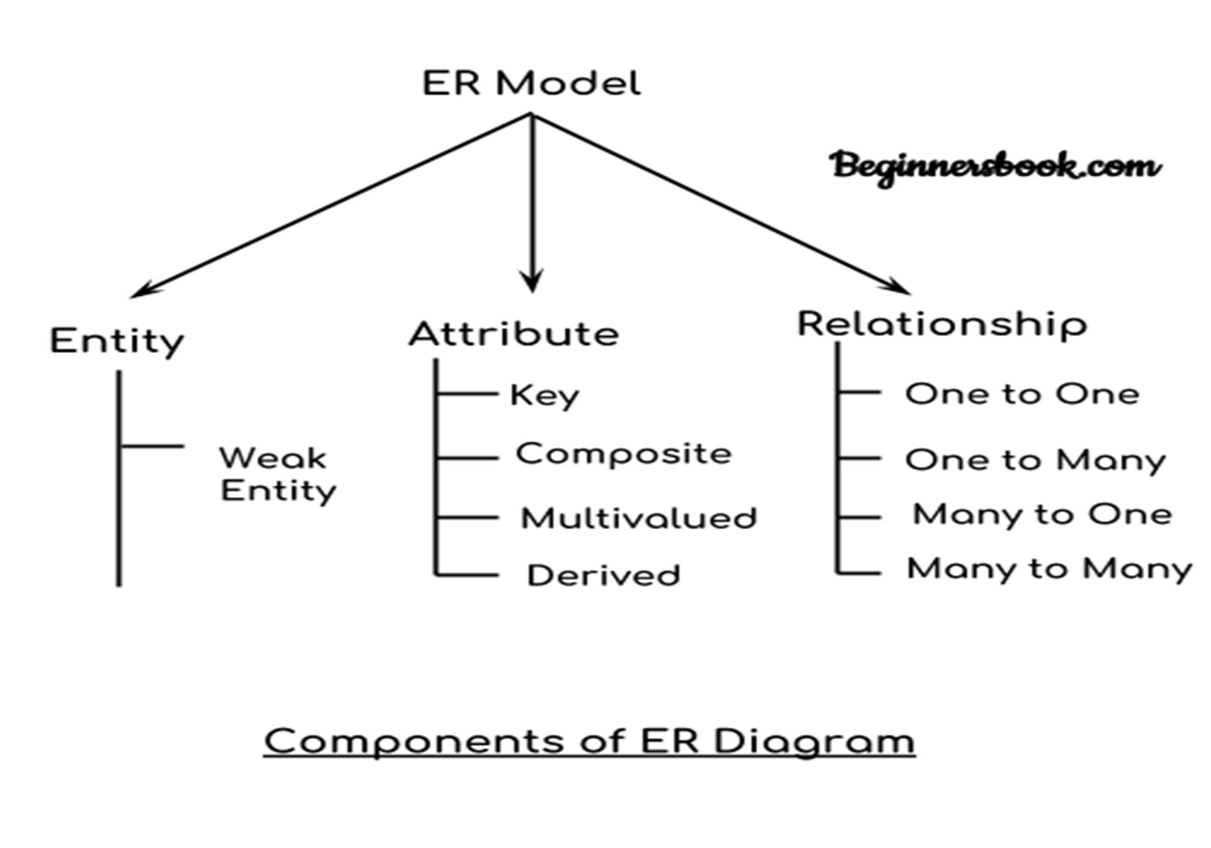
Components of a ER Diagram

As shown in the above diagram, an ER diagram has three main components:
- Entity
- Attribute
- Relationship

Entity
An entity is an object or component of data. An entity is represented as rectangle in an ER diagram.
For example: In the following ER diagram we have two entities Student and College and these two entities have many to one relationship as many students study in a single college. We will read more about relationships later, for now focus on entities.

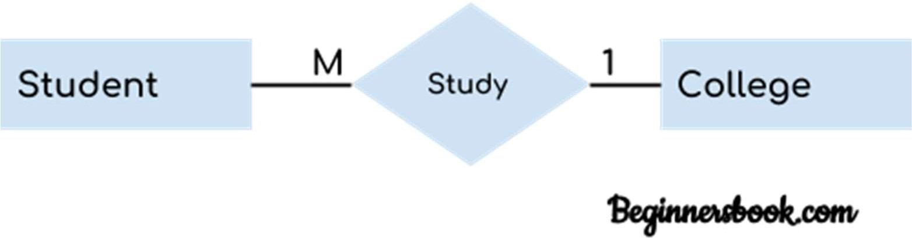

Weak Entity:

An entity that cannot be uniquely identified by its own attributes and relies on the relationship with other entity is called weak entity. The weak entity is represented by a double rectangle. For example – a bank account cannot be uniquely identified without knowing the bank to which the account belongs, so bank account is a weak entity.
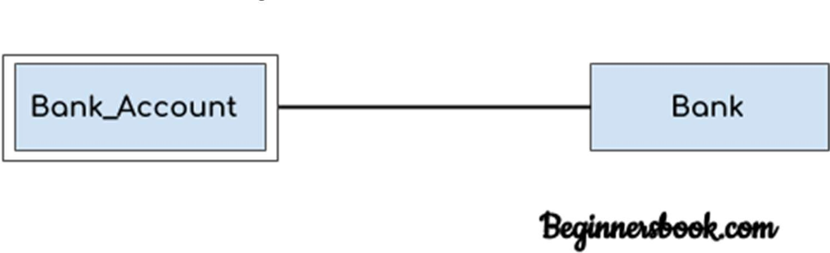

Weak Entities

A weak entity is a type of entity which doesn't have its key attribute. It can be identified uniquely by considering the primary key of another entity. For that, weak entity sets need to have participation.
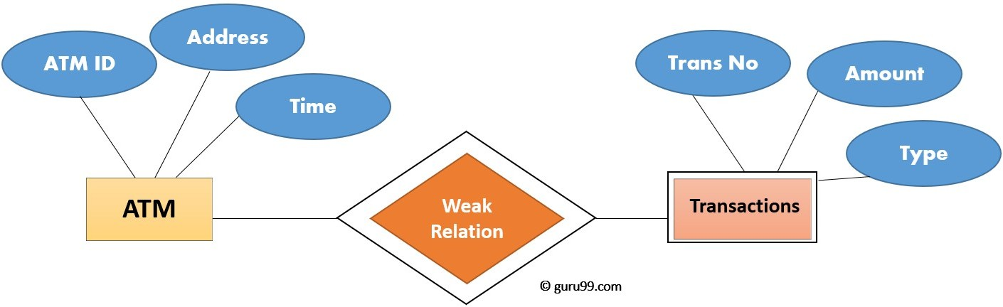

In above example, "Trans No" is a discriminator within a group of transactions in an ATM.Let's learn more about a weak entity by comparing it with a Strong Entity

Strong Entity Set | Weak Entity Set
Strong entity set always has a primary key. | It does not have enough attributes to build a primary key.
It is represented by a rectangle symbol. | It is represented by a double rectangle symbol.
It contains a Primary key represented by the underline symbol. | It contains a Partial Key which is represented by a dashed underline symbol.
The member of a strong entity set is called as dominant entity set. | The member of a weak entity set called as a subordinate entity set.
Primary Key is one of its attributes which helps to identify its member. | In a weak entity set, it is a combination of primary key and partial key of the strong entity set.
In the ER diagram the relationship between two strong entity set shown by using a diamond symbol. | The relationship between one strong and a weak entity set shown by using the double diamond symbol.
The connecting line of the strong entity set with the relationship is single. | The line connecting the weak entity set for identifying relationship is double.

Attribute
An attribute describes the property of an entity. An attribute is represented as Oval in an ER diagram. There are four types of attributes:
- Key attribute
- Composite attribute
- Multivalued attribute
- Derived attribute

Key attribute:
A key attribute can uniquely identify an entity from an entity set. For example, student roll number can uniquely identify a student from a set of students. Key attribute is represented by oval same as other attributes however the text of key attribute is underlined.
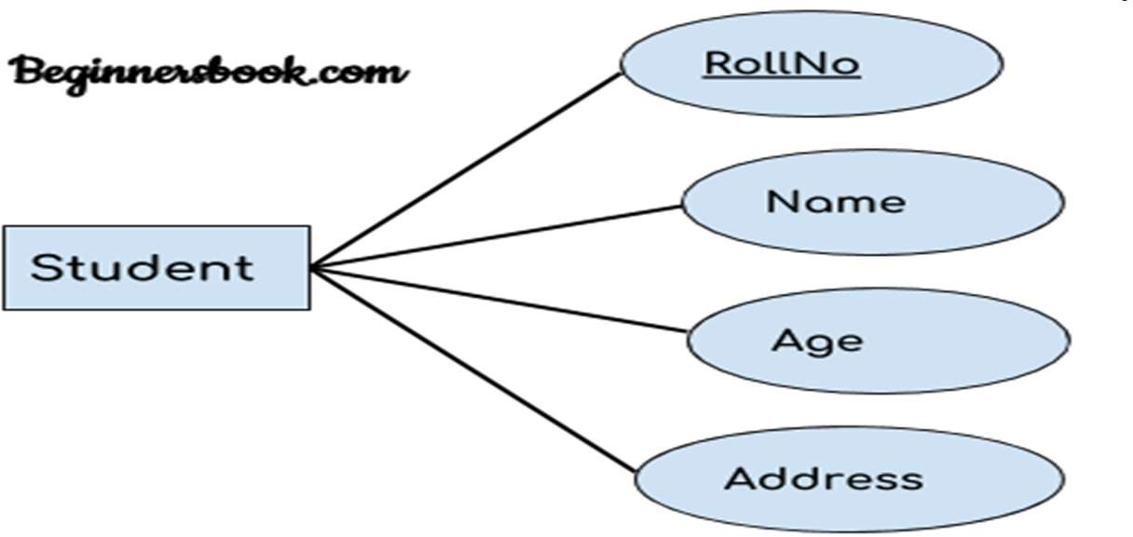

- Composite attribute: An attribute that is a combination of other attributes is known as composite attribute. For example, In student entity, the student address is a composite attribute as an address is composed of other attributes such as pin code, state, country.
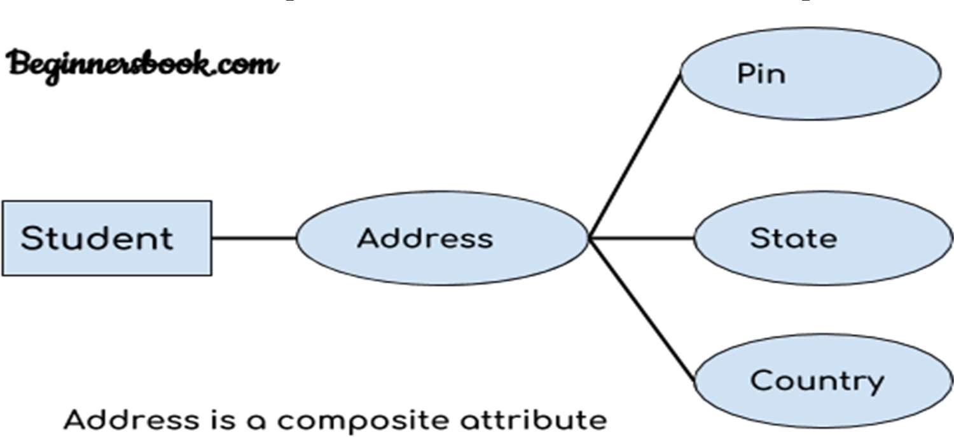

Multivalued attribute:
An attribute that can hold multiple values is known as multivalued attribute. It is represented with double ovals in an ER Diagram. For example – A person can have more than one phone numbers so the phone number attribute is multivalued.

Derived attribute:
A derived attribute is one whose value is dynamic and derived from another attribute. It is represented by dashed oval in an ER Diagram. For example – Person age is a derived attribute as it changes over time and can be derived from another attribute (Date of birth).

E-R diagram with multivalued and derived attributes:
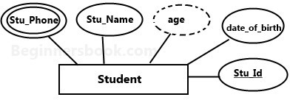

- Relationship Cardinality: Defines the numerical attributes of the relationship between two entities or entity sets.
A relationship is represented by diamond shape in ER diagram, it shows the relationship among entities. There are four types of cardinal relationships:
- One to One
- One to Many
- Many to One
- Many to Many

One to One Relationship
When a single instance of an entity is associated with a single instance of another entity then it is called one to one relationship. For example, a person has only one passport and a passport is given to one person.

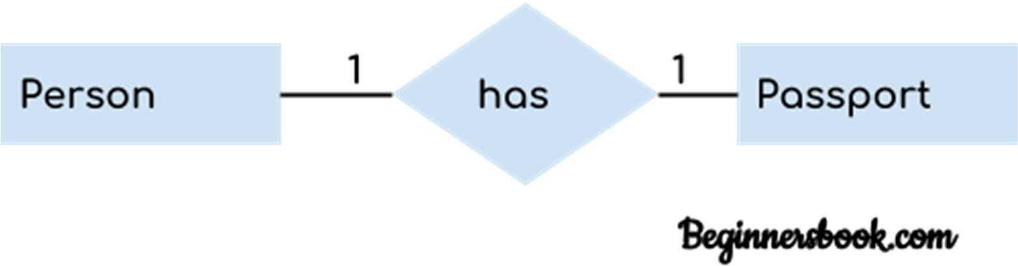

One to Many Relationship
When a single instance of an entity is associated with more than one instances of another entity then it is called one to many relationship. For example – a customer can place many orders but a order cannot be placed by many customers.
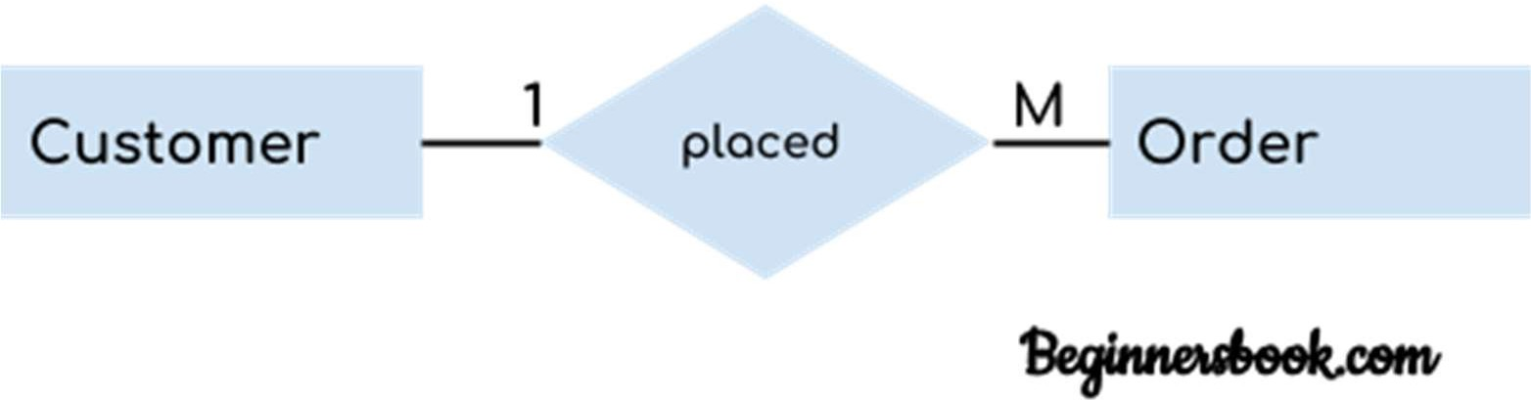

Many to One Relationship
When more than one instances of an entity is associated with a single instance of another entity then it is called many to one relationship. For example – many students can study in a single college but a student cannot study in many colleges at the same time.
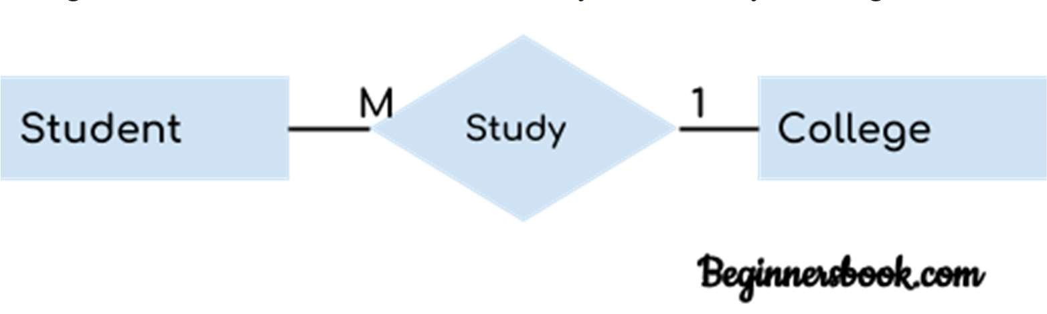

Many to Many Relationship
When more than one instances of an entity is associated with more than one instances of another entity then it is called many to many relationship. For example, a can be assigned to many projects and a project can be assigned to many students.
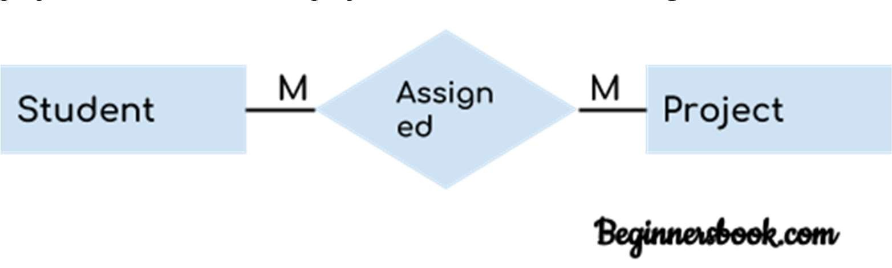

Total Participation of an Entity set
A Total participation of an entity set represents that each entity in entity set must have at least one relationship in a relationship set. For example: In the below diagram each college must have at-least one associated Student.
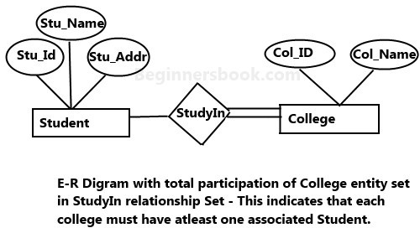

Steps to Create an ERD (E-R Digram)
Following are the steps to create an ERD.
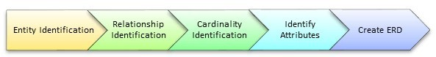
Let's study them with an example:
In a university, a Student enrolls in Courses. A student must be assigned to at least one or more Courses. Each course is taught by a single Professor. To maintain instruction quality, a Professor can deliver only one course

Step 1) Entity Identification
We have three entities
- Student
- Course
- Professor
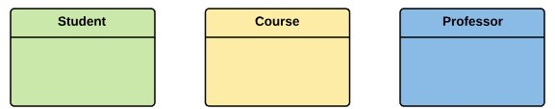

Step 2) Relationship Identification
We have the following two relationships
- The student is assigned a course
- Professor delivers a course
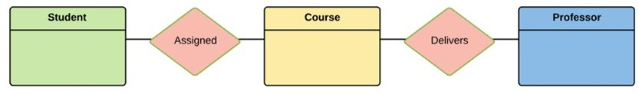

Step 3) Cardinality Identification
For them problem statement we know that,
- A student can be assigned multiple courses
- A Professor can deliver only one course
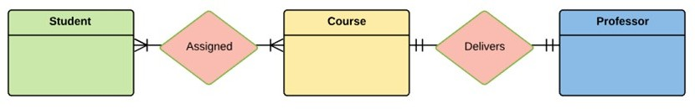

Step 4) Identify Attributes
You need to study the files, forms, reports, data currently maintained by the organization to identify attributes. You can also conduct interviews with various stakeholders to identify entities. Initially, it's important to identify the attributes without mapping them to a particular entity.
Once, you have a list of Attributes, you need to map them to the identified entities. Ensure an attribute is to be paired with exactly one entity. If you think an attribute should belong to more than one entity, use a modifier to make it unique.
Once the mapping is done, identify the primary Keys. If a unique key is not readily available, create one.

Entity | Primary Key | Attribute
Student | Student_ID | StudentName
Professor | Employee_ID | ProfessorName
Course | Course_ID | CourseName
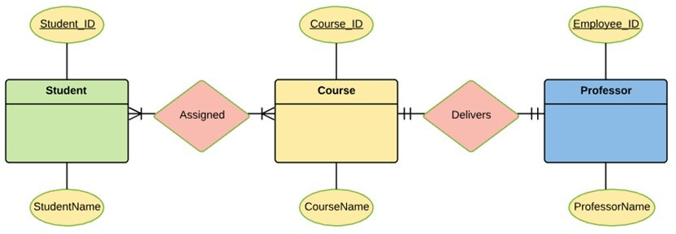
For Course Entity, attributes could be Duration, Credits, Assignments, etc. For the sake of ease we have considered just one attribute.

Step 5) Create the ERD
A more modern representation of ERD Diagram
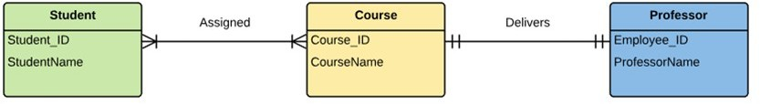

Best Practices for Developing Effective ER Diagrams
- Eliminate any redundant entities or relationships
- You need to make sure that all your entities and relationships are properly labeled
- There may be various valid approaches to an ER diagram. You need to make sure that the ER diagram supports all the data you need to store
- You should assure that each entity only appears a single time in the ER diagram
- Name every relationship, entity, and attribute are represented on your diagram
- Never connect relationships to each other
- You should use colors to highlight important portions of the ER diagram

Summary
- The ER model is a high-level data model diagram
- ER diagrams are a visual tool which is helpful to represent the ER model
- Entity relationship diagram displays the relationships of entity set stored in a database
- ER diagrams help you to define terms related to entity relationship modeling
- ER model is based on three basic concepts: Entities, Attributes & Relationships
- An entity can be place, person, object, event or a concept, which stores data in the database

- Relationship is nothing but an association among two or more entities
- A weak entity is a type of entity which doesn't have its key attribute
- It is a single-valued property of either an entity-type or a relationship-type
- It helps you to defines the numerical attributes of the relationship between two entities or entity sets
- ER- Diagram is a visual representation of data that describe how data is related to each other
- While Drawing ER diagram you need to make sure all your entities and relationships are properly labeled.

